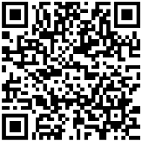
School of Psychological Science
12a Priory Road
BRISTOL BS8 1TU
United Kingdom
DopaMINE-study@bristol.ac.uk
Study Site www.bristol.ac.uk
0117 455 8224
PARTICIPANT INFORMATION SHEET: DopaMINE 5 Study
Scan the QR code above to view online study materials. This website will also contain a link to register your interest in taking part in the study.

You are being invited to take part in a research study because you have a recent diagnosis of Attention Deficit Hyperactivity Disorder (ADHD). ADHD patients are being recruited for this study to investigate how their medicine affects their brain, body, and behaviour. Before you decide whether to take part, it is important for you to understand why and how the research is being done. Please take time to read the following information carefully and discuss it with others if you wish. Remember that your participation is voluntary.

What is the purpose of the study?
This study aims to investigate the relationship between dopamine and how our brains work. As our tears and blood contain dopamine, we will investigate what they can tell us about the brain. This could be helpful for future research and healthcare.
We will also aim to explore how your medication affects your ADHD symptoms, your dopamine levels, and how you think and behave. We will compare your results with participants who don’t have ADHD so that we can understand more about how dopamine is involved in these things.
What will I have to do?
The study will be conducted over two sessions, and you will need to attend both of these. Each session will involve a number of tasks, with breaks between each activity. Each session will last no more than 1 hour. The tasks include:
- Tear Fluid Collection (“The Schirmer Test”). A strip of filter paper will be placed within your lower eyelid for a few minutes to absorb a tear fluid sample (shown in image 1 below). You may find this mildly uncomfortable, but it will last for only a few minutes.
- Blood Collection. We will collect a very small sample of your blood (0.5 millilitres, or one tenth of a teaspoon) from your arm using a Tasso device (shown in image 2 below). These devices are designed to be as painless as possible, but you may feel some discomfort. This will take five minutes.
- Drug Dose Calculation. To understand how your ADHD medication affects you, we need to work out your dose. For this, we will weigh you at the beginning of the second session and ask for details of your prescription, to understand how many grams of medication you take per kilogram of body weight. This will be anonymised.
- Random Number Generation. Random number generation has been linked to Working Memory, which is impacted by ADHD. We will ask you to generate a random sequence of numbers, using the numbers 1 to 9, for three minutes.
- ADHD Self-report Questionnaires. You will complete some standard self-report questions used to measure ADHD symptoms and how they affect you. These should take 5-10 minutes to complete.
- Item Sorting Task. You will only complete this activity once. In this task, you will use a computer to sort items (as quickly and as accurately as possible) into shopping baskets depending on who owns them. The task will take around 15 minutes.
- Endowment Task. In this task you will assign buying and selling prices to 8 common items. This should take 5-10 minutes.
We will also collect basic data on your age, sex, ethnicity, education, and neurodivergence for demographic and inclusion purposes.
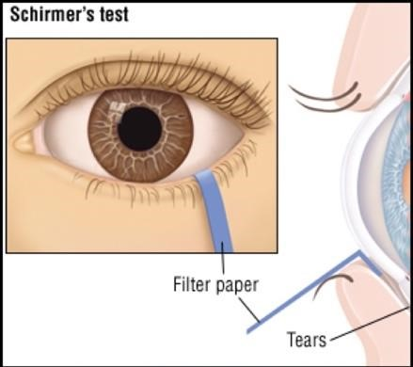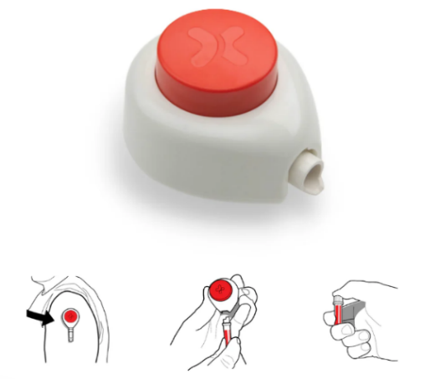
Image 1. Caption:
An image showing how the Schirmer Test is used to collect tear fluid. The image shows a folded strip of filter paper tucked within the lower eyelid, to absorb a sample of the tear fluid which collects there.
Image 2. Caption:
A Tasso device, with images showing how the device is then used to collect a blood sample from the upper arm.
How much time will the study take?
Each study session will last around one hour, so the study will take roughly two hours over two sessions on separate dates. We would like you to attend both sessions.
Am I eligible to take part?
In order to take part, you must:
- Be aged between 18 years and 35 years
- Have typical colour vision (no colour blindness) and typical visual acuity (your vision can be corrected with glasses or contact lenses)
- Have no history of eye health problems (including dry eye disease diagnosis)
- Have been a resident in the UK for at least 2 years
- Be a fluent English speaker
- Not be taking any medication prescribed for a diagnosed mental health or neurological condition (except for ADHD medication in Session 2)
- Not be a daily user of any recreational substances (e.g., nicotine, alcohol, cannabis)
- Not have taken caffeine or any recreational substances (e.g., nicotine, alcohol, cannabis) for at least 24 hours before your allotted testing session
- Have no past or present diagnosis of a substance use disorder
- Have no diagnosis of a bleeding disorder (e.g., von Willebrand Disease, Haemophilia A/B)
- Not currently be taking anti-coagulant medication
- Have no diagnosis of a blood-borne disease (e.g., HIV, Hepatitis B/C)
Expenses and reimbursement
You will be required to come to the University of Bristol (BS8 1TU) for two testing sessions that will take place approximately 2-3 weeks apart. You will be paid £50 for participating in the study (£25 after each session).
Do I have to take part?
It is up to you to decide whether you want to take part. Participants will be asked to complete a consent form before beginning. You will be free to withdraw at any time and without giving a reason, by telling us in person or in writing. You would not then need to complete further activities relating to the study. A decision to withdraw or not take part would not affect your treatment or be held against you in any way.
What will happen to the samples that I give?
Your samples will be labelled with your participant number, so that they cannot be traced back to you. Each sample will be processed in our laboratory to extract its tear fluid or serum, which will then be frozen at -80°C until analysis. Any unused sample components will be disposed of via the University of Bristol’s clinical waste disposal procedures. Samples will be analysed using a chemical test called an ‘ELISA’ (enzyme-linked immunosorbent assay). When the study is complete and all samples have been analysed, any remaining whole or partial samples will be disposed of via the University of Bristol’s clinical waste disposal procedures.
What are the possible disadvantages and risks of taking part?
The risks associated with participation in the study are expected to be no greater than what you might experience in your day-to-day life. There are risks of irritation from the blood and tear fluid collection, but these tasks will be performed by fully trained researchers using sterile equipment and following strict protocols.
What are the possible benefits of taking part?
You would not directly benefit from taking part in this research study and your participation is voluntary. The information we get from this study may help lots of people, by helping us to understand more about medication and our bodies.
What if there is a problem?
If you wish to raise any concerns about any aspect of the way you've been approached or treated in this study, please contact DopaMINE-study@bristol.ac.uk.
Who has reviewed the study?
This study has received ethics approval from the NHS Research Ethics Committee (reference: 338580). If you have any concerns related to this study, please direct them to the University of Bristol Research Governance Team (RGT) via research-ethics@bristol.ac.uk.
Who can I contact for further information?
If you have any questions about the study at any time, please contact the research team (DopaMINE-study@bristol.ac.uk) at the University of Bristol.

